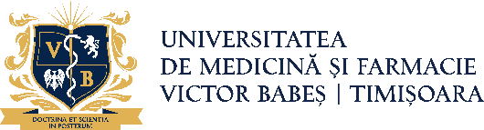
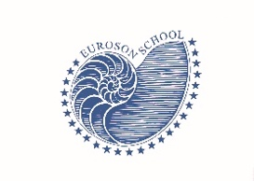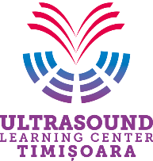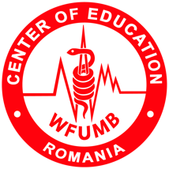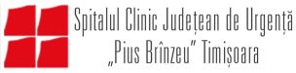

EUROSON SCHOOL
SMALL PARTS
Timișoara 23-25 April 2026
COURSE DIRECTOR: DANA STOIAN

THURSDAY 23.04.2026
 |  | ROOM 2 SMALL PARTS BREAST
 | SESSION I | Chairman: Dana Stoian, Adrian Lim
14.00-14.25 | Simona Cerbu | Imaging benign versus malignant lesions
14.25-14.50 | Dana Stoian | New BIRADS diagnostic
14.50-15.10 | Vito Cantisani | MPUS breast pathology evaluation
15.10-15.30 | Adrian Lim | Pitfalls in Breast US
15.30-15.50 | Dana Stoian | Lumps and Bumps Breast
15.50-16.00 |  | Discussion
16.00 -16.30 | Coffee Break | Coffee Break

 |  | ROOM 2 SMALL PARTS GENITAL
 | SESSION II | Chairman: Răzvan Bardan, Zeno Spârchez
16.30-16.50 | Vito Cantisani | Multimodal scrotal evaluation
16.50-17.10 | Zeno Spârchez | Trauma /emergency Penile US evaluation
17.10-17.30 | Răzvan Bardan | Functional penile ultrasound in MSD diagnostic
17.30-17.50 | Răzvan Bardan | Role of clitoridean US in FSD diagnostic
17.50-18.10 | Hans Peter Weskott | Lymph nodes MPUS evaluation (outside the thorax)
18.10 – 18.30 | All | Discussions
18.30 – 19.00 | OPENING CEREMONY

FRIDAY 24.04.2026
ADVANCED ULTRASOUND TECHNIQUES IN CLINICAL PRACTICE - "THE MULTIPLE FACES OF ULTRASONOGRAPHY"
 |  | ROOM 2 SMALL PARTS NECK
 | SESSION III | Chairman: Alexandru Caraba, Hans Peter Weskott
09.00-09.20 | Simona Cerbu | Salivary glands US INTRO
09.20-09.40 | Alexandru Caraba | Sialolithiasis, sialadenitis, Sjogren sd
09.40-10.00 | Manuela Lenghel | Salivary glands tumors - how to differentiate benign vs malignant
10.00-10.20 | Anna Drelich Zdroja | Neck vascular pathology
10.20-10.40 | Hans Peter Weskott | CEUS in carotid plaques, any clinical relevance?
10.40-11.00
11.00-11.30 | Coffee Break | Coffee Break

 |  | ROOM 2 SMALL PARTS LYMPH NODES
 | SESSION IV | Chairman: Simona Cerbu, Dana Stoian
11.30-11.50 | Dana Stoian | Stations of the neck
11.50-12.10 | Manuela Lenghel | Pathology of the lymph nodes – Multimodal US
12.10-12.30 | Adrian Lim | Role of CEUS in lymph node characterization
12.30-12.50 | Octavian Neagoe | Invasive procedures in lymph node pathology
12.50-13.00 |  | Discussions
13.00-14.00 | Lunch Break | Lunch Break

ROOM 2 SMALL PARTS
THYROID
 | SESSION V | Chairman: Octavian Neagoe, Vito Cantisani
14.00-14.20 | Vito Cantisani | Multimodal thyroid nodular disease approach
14.20-14.40 | Mihaela Vlad | FNAB indications
14.40-15.00 | Octavian Neagoe | FNA/CORE BIOPSY Technique
15.00-15.20 | Andreea Bena | CEUS in thyroid disease: diagnostic criteria and pitfalls
15.20-15.40 | Mihai Marinescu | Therapeutical indication and goals of interventional thyroid procedures
15.40-16.00 | Daniel Diaconu | Radio ablation techniques
16.00-16.30 | Coffee Break | Coffee Break

 |  | ROOM 2 SMALL PARTS – Lumps and Bumps
 | SESSION VI | Chairman: Manuela Lenghel, Zeno Spârchez
16.30-17.20 |  | THE BEST FROM OUR PARTNERS  MEDIST-GE 10 MIN  SUPERMEDICAL – SIEMENS 10 MIN  ITRADEPHARMA 10 MIN
17.20 – 17.40 | Manuela Lenghel | Lumps and Bumps Neck
17.40 – 18.00 | Zeno Spârchez | Interventional in Lumps and Bumps
18.00 – 18.10 |  | Discussions

17.40 – 18.30 EFSUMB EXB MEETING
20.00 Get together party.

SATURDAY 25.04.2026
 |  | ROOM 2 SMALL PARTS
 | SESSION VII | Chairman: Mihaela Vlad, Ioana Golu
09.00 – 9.20 | Ioana Golu | CASE REPORTS
09.20-09.40 | Andreea Bena | CASE REPORTS
09.40-10.00 | Oriana Pelineagra, Stefania Bunceanu | CASE REPORTS
10.00– 10.20 | Coffee Break | Coffee Break
10.20-10.40
10.40-11.00
11.00-11.20
11.20-11.40 | Octavian Neagoe, Diana Streinu | Hands On FNAC
11.40-13.30 | Mihai Marinescu, Daniel Diaconu | Hands On Thermal ablation

